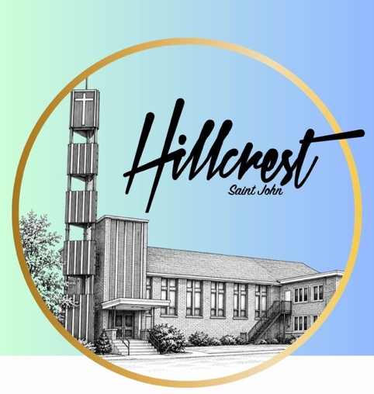
Hillcrest is looking for an Associate Pastor of Adult and Community Hillcrest Baptist Church
476 Lancaster Avenue
Saint John NB E2M 2L6

October 6, 2026

Dear Candidate,
The Search Committee of Hillcrest Baptist Church welcomes you to apply for the position of full-time Associate Pastor of Adult and Community Ministries. You would be working with the Pastoral Team to lead Hillcrest members, guests and our wonderful Saint John West side community to a closer relationship with Jesus!

Saint John is a city of a little over 78,000 people. It is spread over a vast space identified with the four directions of a weather vane. The areas have vistas and views that will take your breath away and fill you with the love of God. Surrounding communities add to the mix of beauty. Also shared in the city are Rockwood and Irving Nature Parks both with many walking trails, and the ocean sites from Mispec and Saint’s Rest, to New River Beach.

Separated from the rest of the city by two bridges, the west side is where Hillcrest is. The church is on top of a knoll and for years has been called “The Beacon on the Hill”. It has a reputation for the help it gives not only on Sundays but with numerous community resources filling bellies and clothing those in need. Soul Food and the Caring Closet have doors open for anyone, and we are humbled with the ability to share in God’s serving.

These and other Ministries are very important to Hillcrest and we want to continue growing and giving the best we can. If you are enthusiastic, interested in sharing and collaboratively taking on roles for our church and community, please apply in respect to the Job Description to the following emails.

Accepting Resumes from now until – December 1, 2026.
Co-Chairs: Nancy Steele nancy.steele@rogers.com
Janice Shonaman jng@nb.sympatico.ca

Sincerely,
Hillcrest Search Committee

